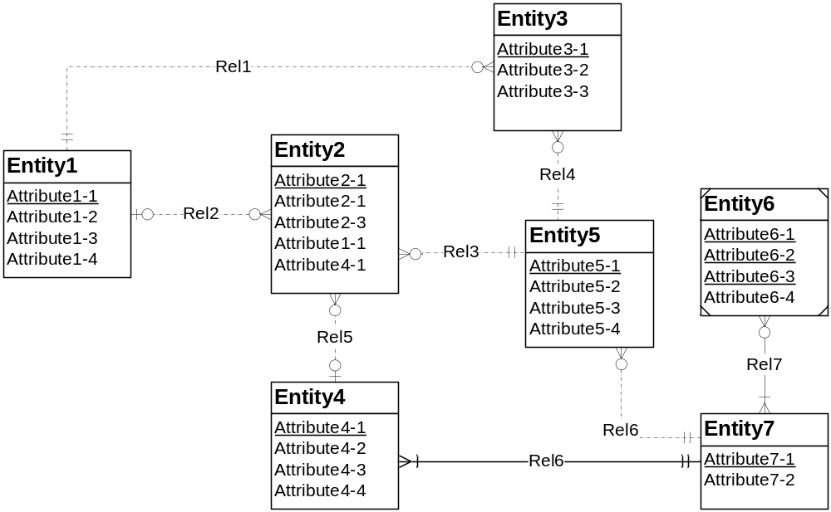
Figure 1: ERD for Problem 4

- Resolution of the identifying relationship rule: The problem can be resolved by adding one or more weak entities or making the relationship (Rel6) non-identifying.
- Resolution of the identification dependency cardinality rule: The problem can be resolved by changing the weak entity’s cardinality in Rel7 to (1,1).
- Resolution of the redundant FK rule: Normally the problem can be resolved by removing the redundant foreign keys (Entity2.Attribute1-1 and Entity2.Attribute4-1). If the attribute does not represent a foreign key, it should be renamed instead of removed.
- Repition of attribute names in a table: Entity2.Attribute2-1 name is repeated twice. The attribute name Attribute2-1 should be changed to Attribute2-2 for any one of the attribute.

